Elastic Container Service (ECS)

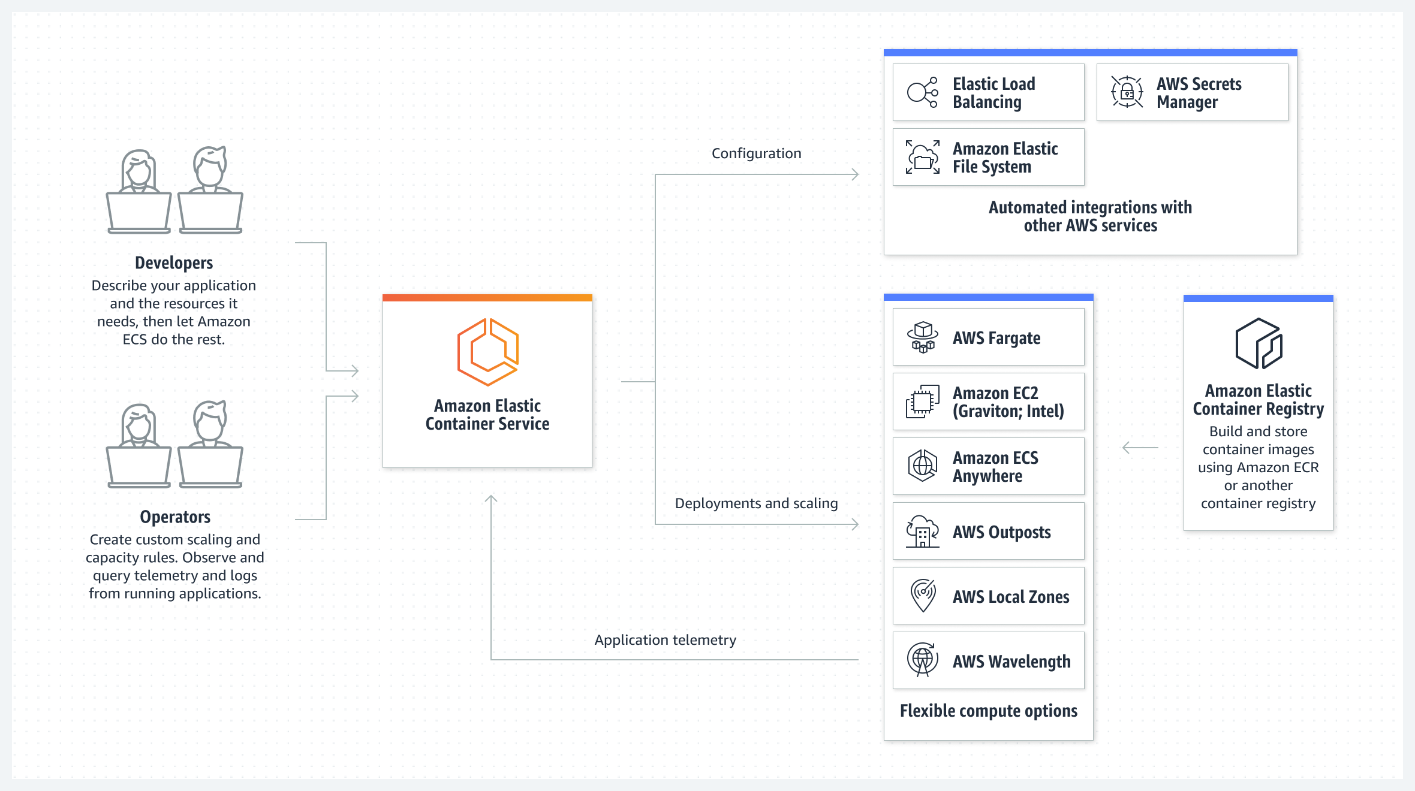

Task Title
ECS-01
Objective
The objective of this task is to watch the ECS-01 video posted on slack and worked on executing the initializing ECS shown in video.
Prerequisites
List all requirements before starting:
- Cluster
- CloudFormation Stack
- Events
- Agent
- Tasks
- Task Definition
- Services
- Load Balancer
- Target
- Deployment Strategies

Issues Faced: Briefly mention issues and how you fixed them. Posted below in the last.
Conclusion
Conclusion has been provided for every task at the end.

Tasks

- Setup a highly available ecs cluster with load balancer and dynamic port mapping.
NOTE:
Your cluster should maintain at least 6 tasks at any point of time and should be highly available across multiple AZ's.
Use the below image from deployment:
sabair0509/hiring-app:works

Objective: Setting up high available ecs cluster with load balancer and dynamic port mapping in Elastic Container service.
We shall use ECS cluster with 2 ec2’s and 6 Containers where it will get managed by creating Load Balancer and Targets to make sure to verify health checks and auto scale accordingly.

- We have image provided in the requirements, so this will be straight forward task.

Flow:
User → ALB → Target Group → Tasks → Containers on EC2 machines
Now YOU manage:
instance type
scaling
patching
disk
cost optimization

What we Must Achieve
✔ At least 6 running tasks
✔ Spread across multiple Availability Zones
✔ Dynamic port mapping (no fixed host port)
✔ Load balancer distributes traffic
✔ Auto-healing if a task dies

Main Components
We will create:
- VPC with public subnets in 2+ AZ
- Application Load Balancer
- Target Group (IP type)
- ECS Cluster
- Task Definition
- ECS Service (desired count = 6)

Step by step Implementation
Step 1: Navigate to ECS and create a cluster
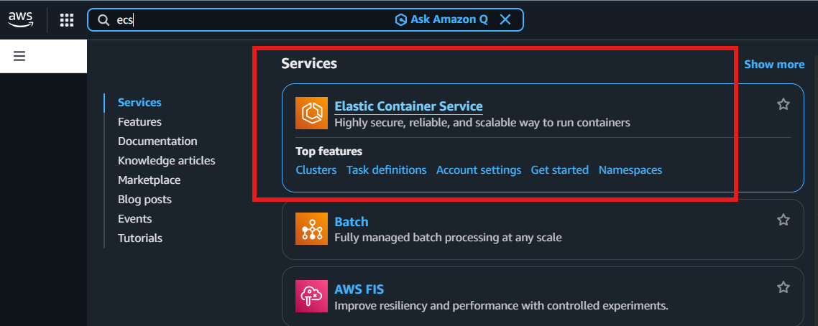

Create a Cluster
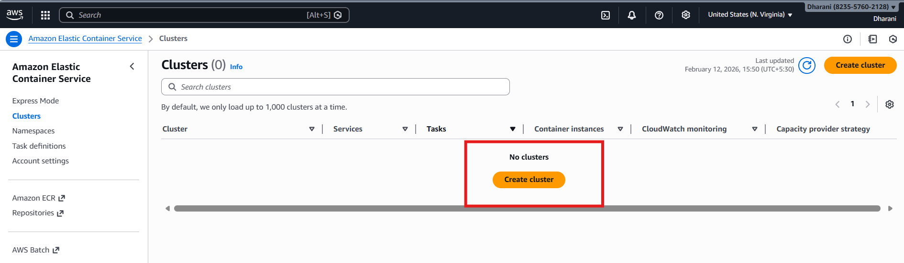

- Cluster name- Techie-App-Dev
- Infrastructure- Fargate and Self-managed instances
- ASG- Create a new ASG
- Provision Model- On-Demand instance
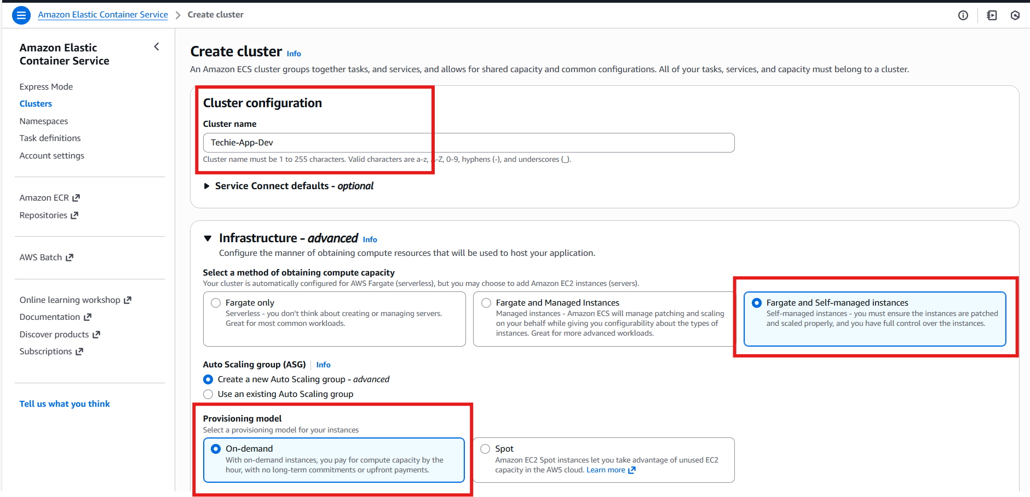

- Created a new keypair- ECS

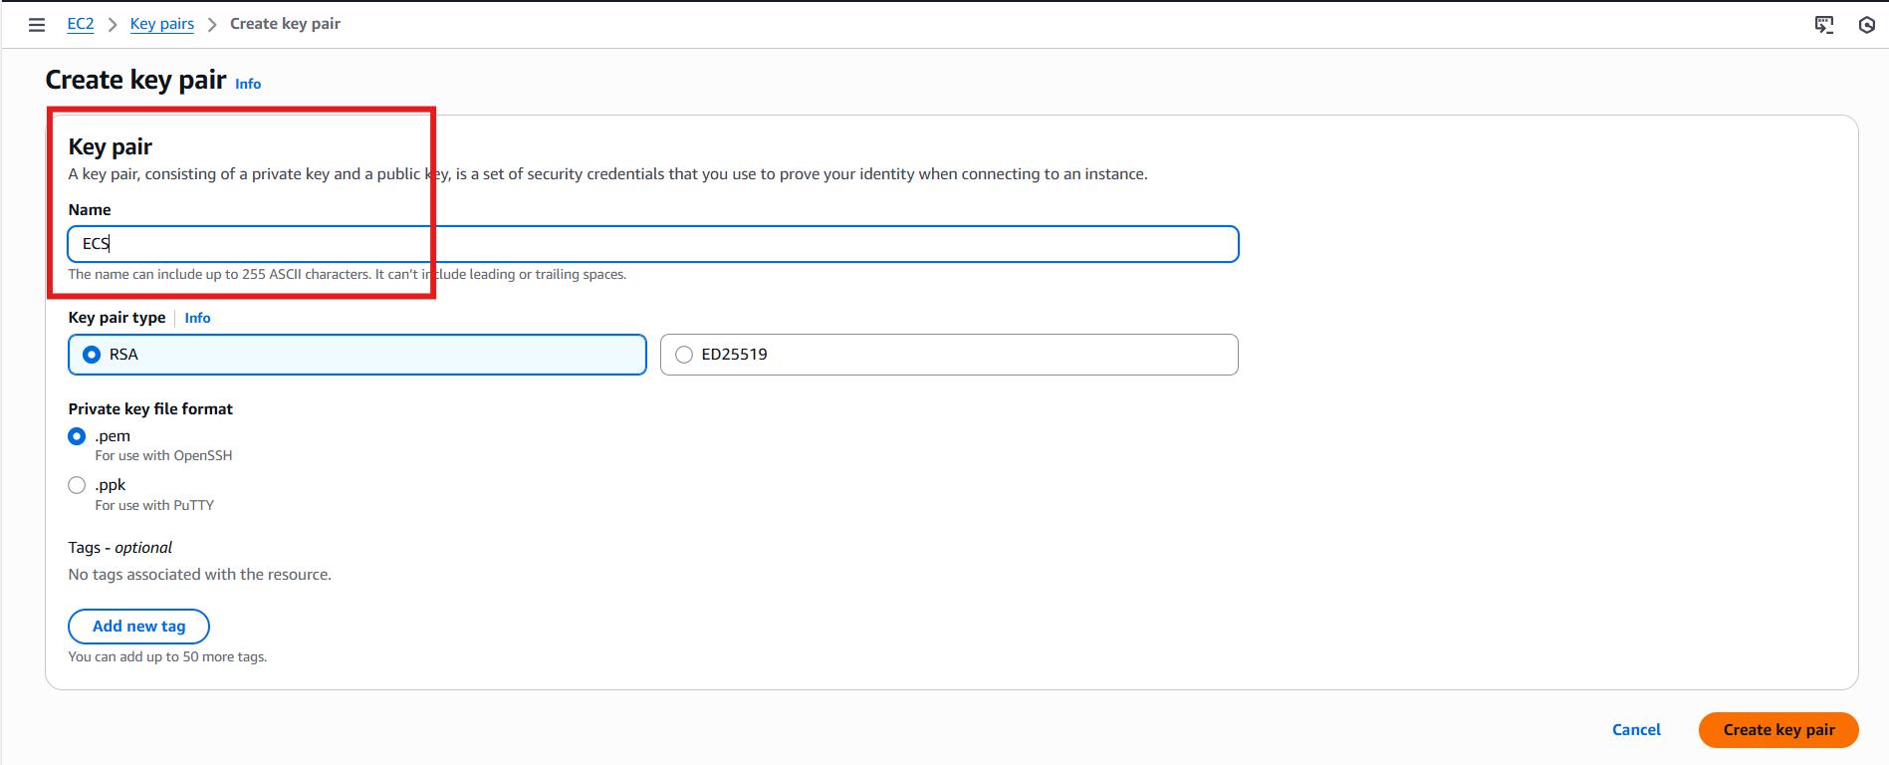

- AMI- Amazon Linux 2023
- EC2 Instance Type- m7i.large
- IAM- I have asked to create automatically
- Desired Capacity- Min:2 and Max:3
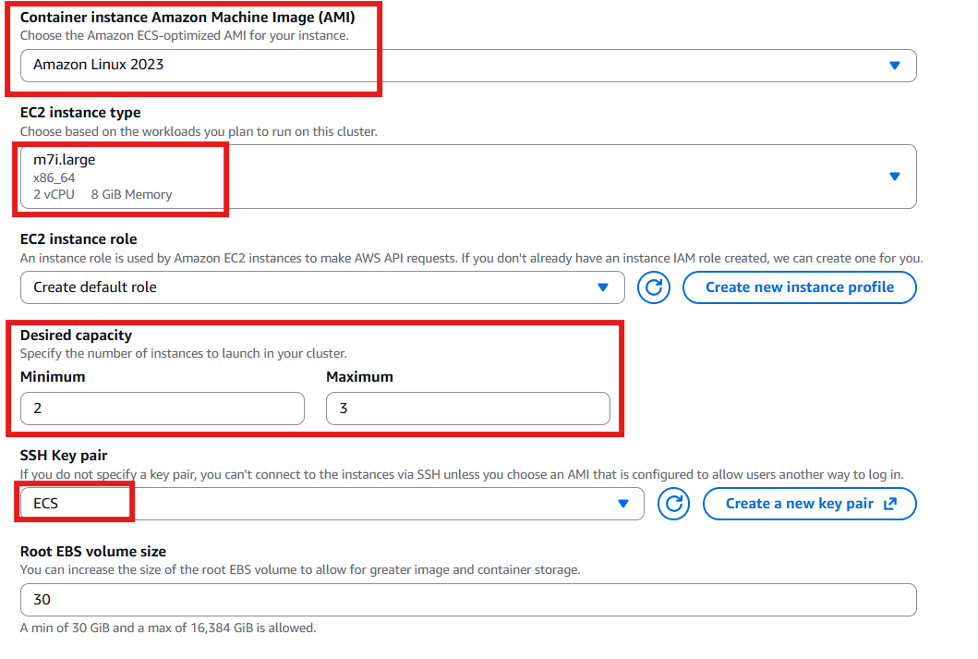

Cluster is getting created in background
- Cluster will get created with the help of CloudFormation stack. CloudFormation will help us to create Clusters, Security groups, VPC’s, subnets etc. in the background

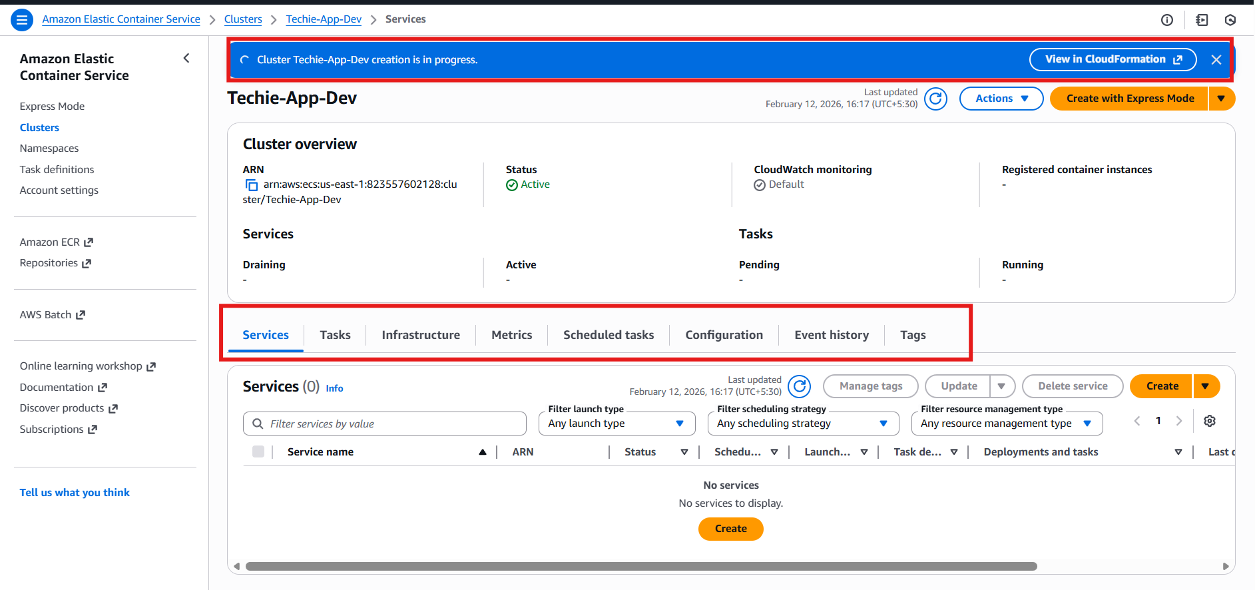

Step 2: Run a new task
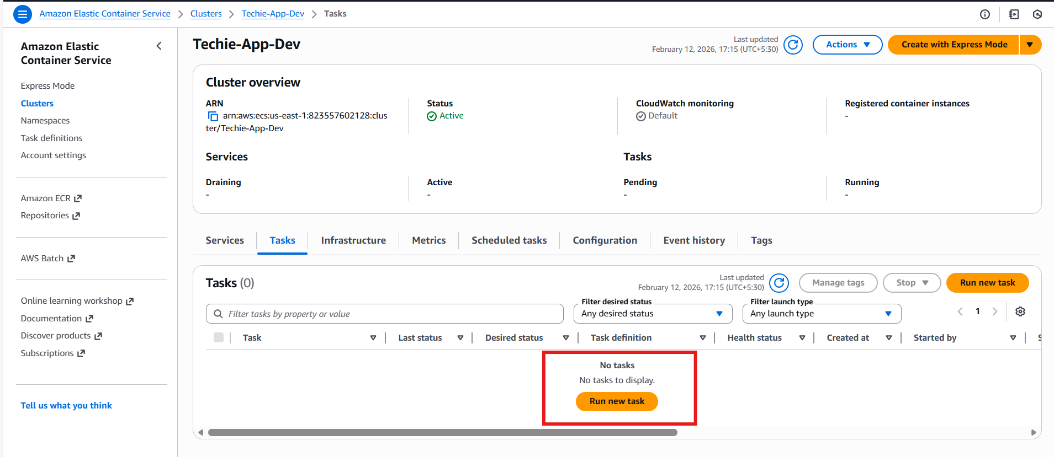

Step 3: Create a new task definition
Why do we need to create a task definition?
Ans. Because, Task definition is like a blueprint of our containers. What do we define inside, it will get executed the same.
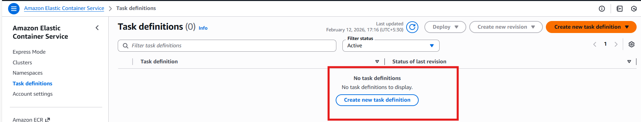
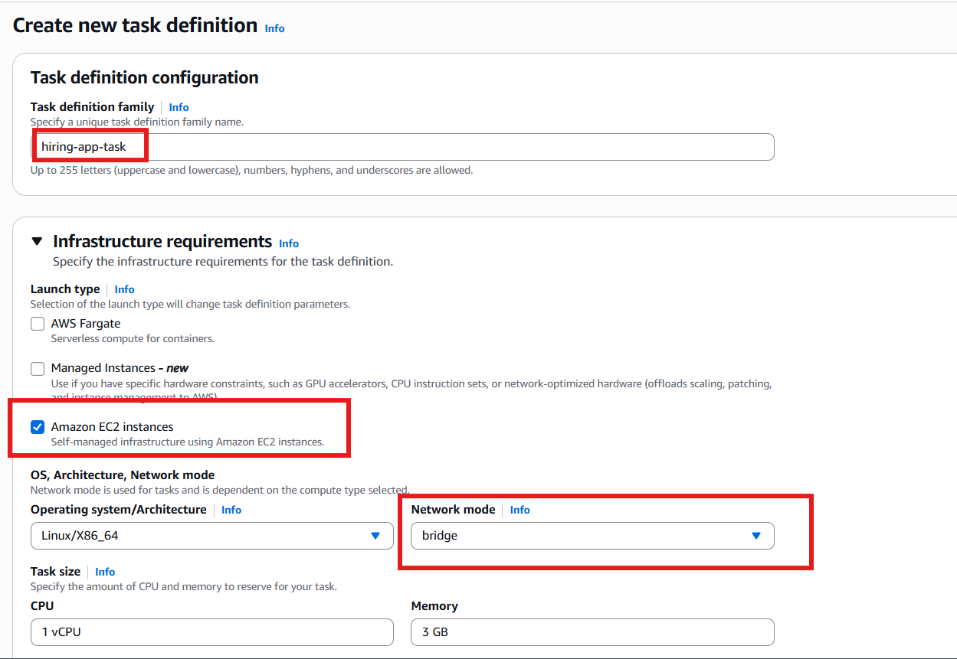

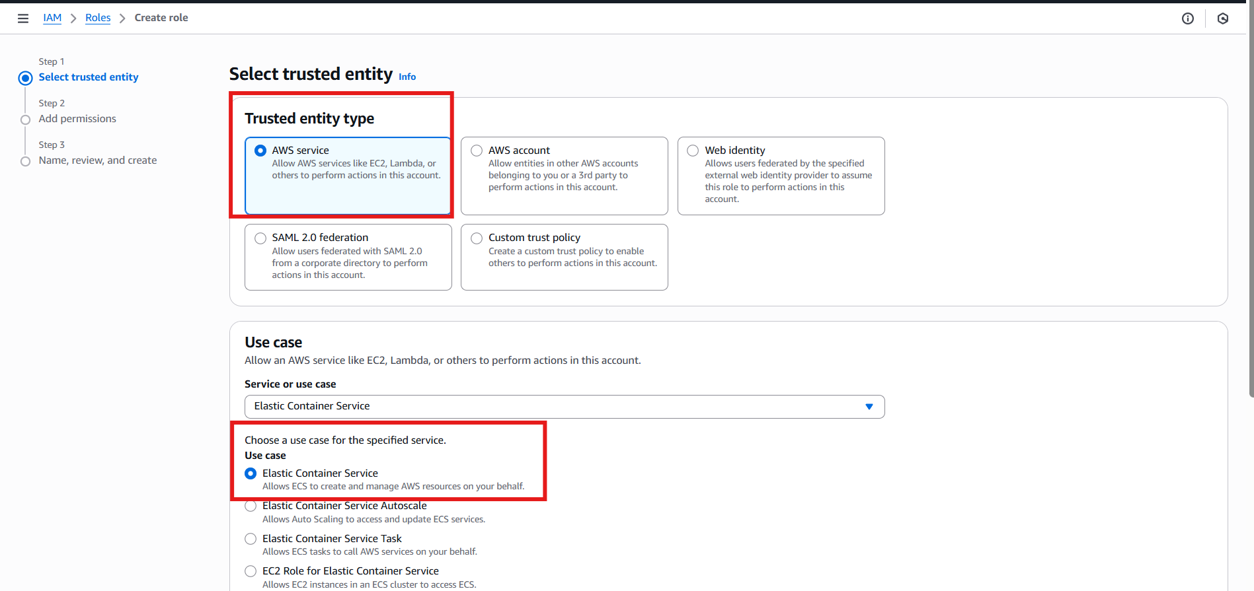

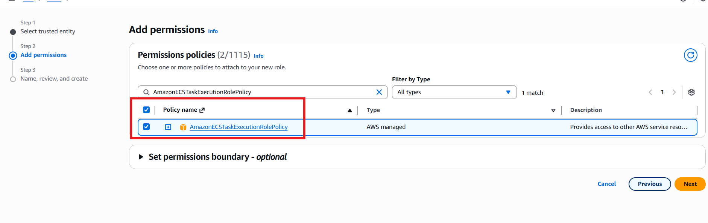
If interviewer asks:
What is task execution role?
Answer:
It allows ECS agent to pull images and send logs to CloudWatch.
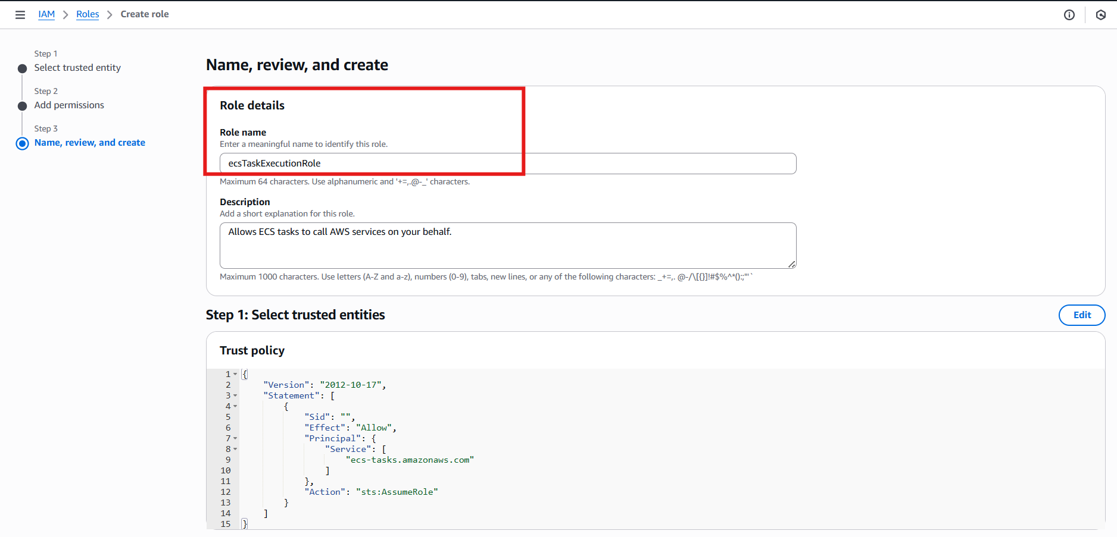

- Task execution role- → pull image, push logs.
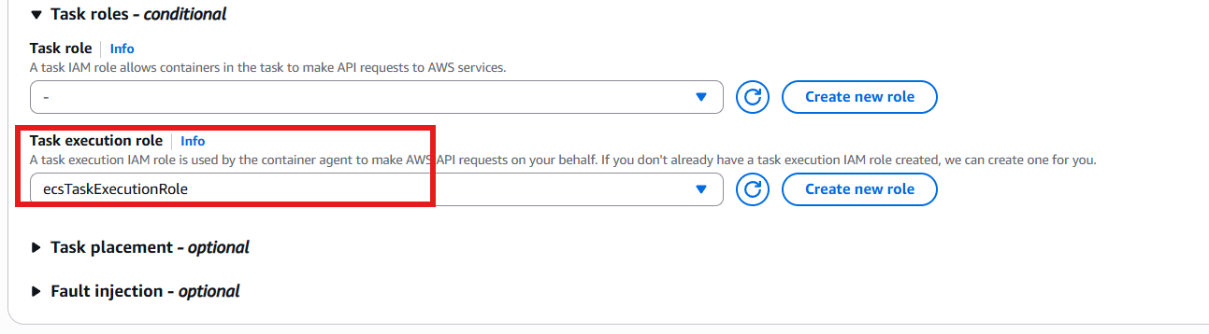

Host Port- 0 (Because it will take dynamically to allow any port).
Container Port- 8080

We have to provide only 1 container in Task Definition, so it will take the replica for other ones from Service.
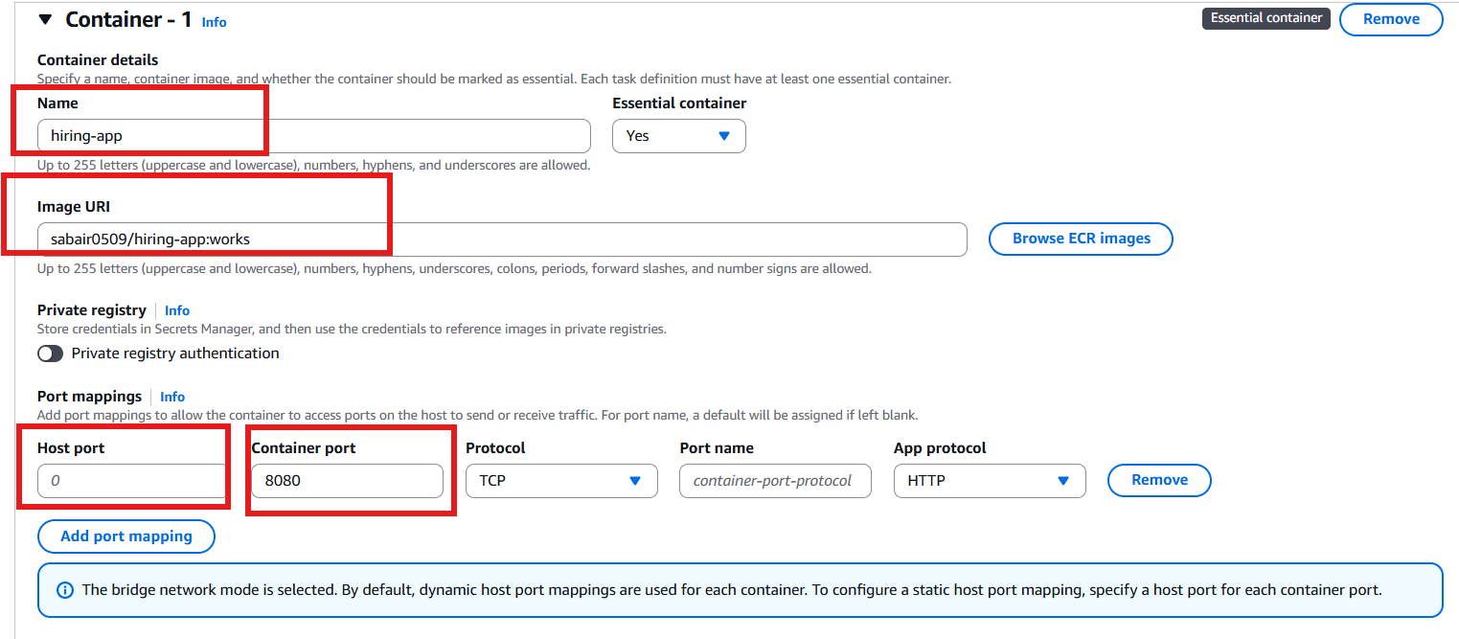

- Task Definition successfully created
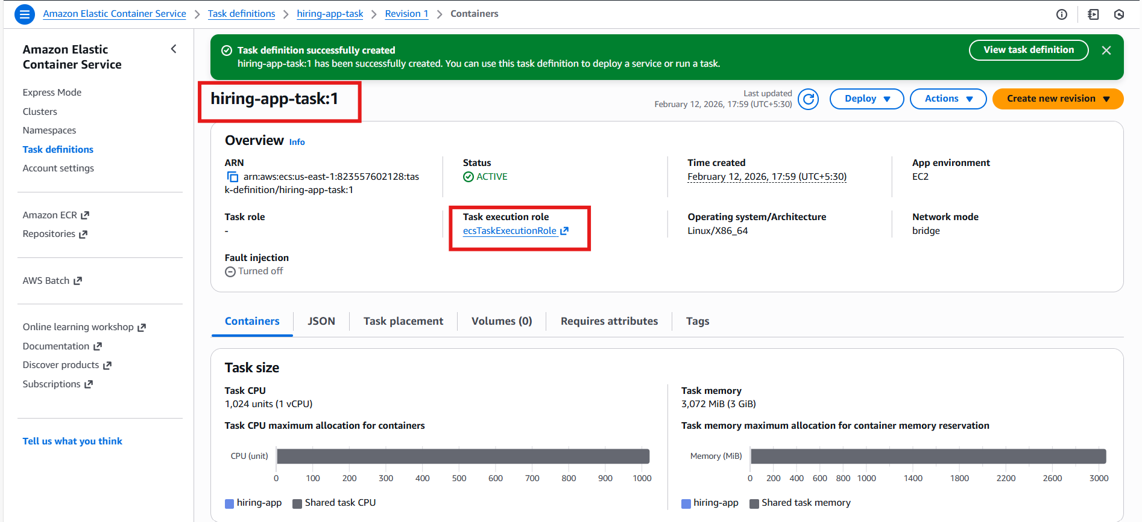

Step 4: Create a new service
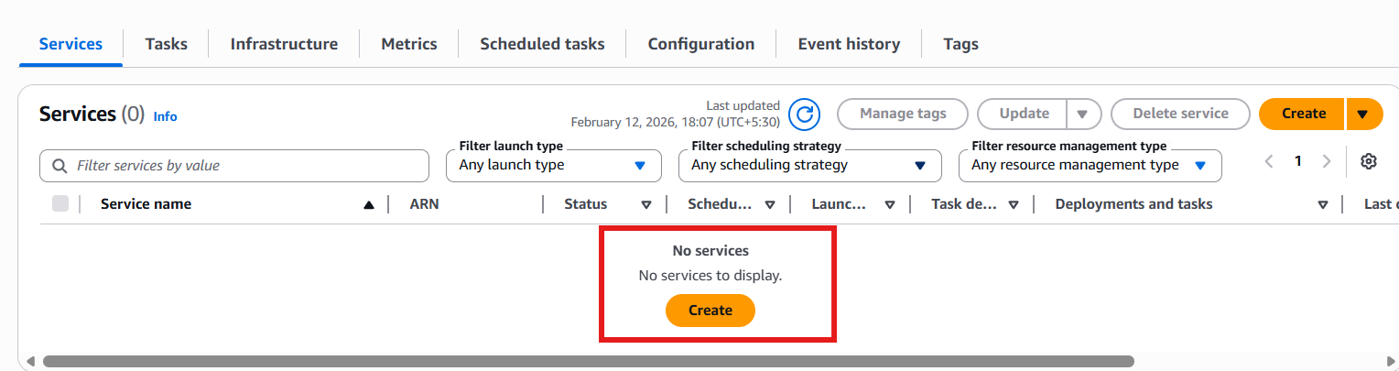

Task definition revision- will be based on how many times the revision has been performed.
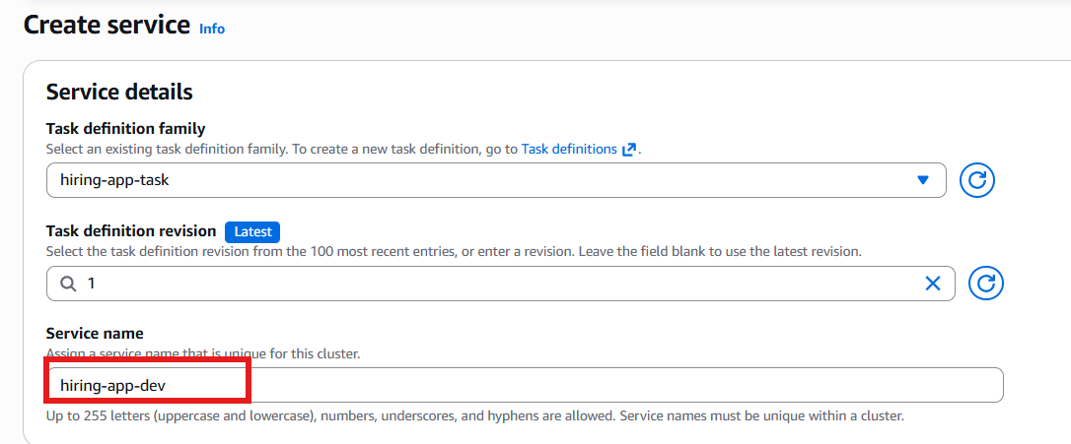
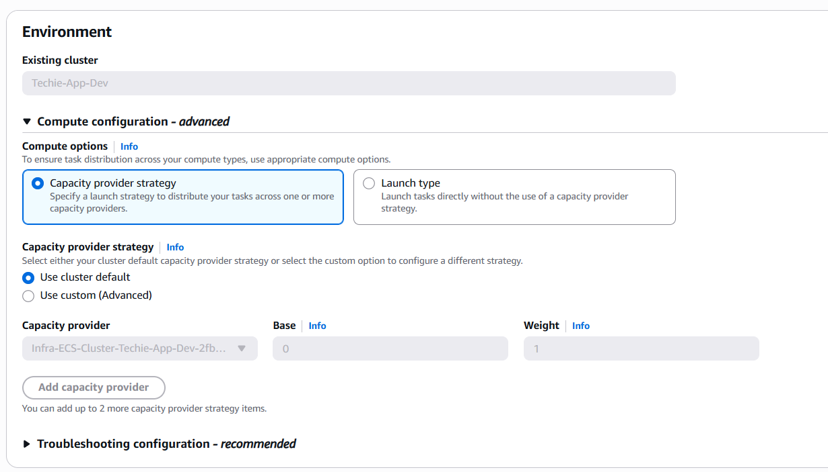
- Deployment configuration- Replica

- What is Replica: Replica service place and maintain a desired of tasks around your cluster.

Example: If 5 containers were working previously, then replica will make sure to maintain min 5 containers.

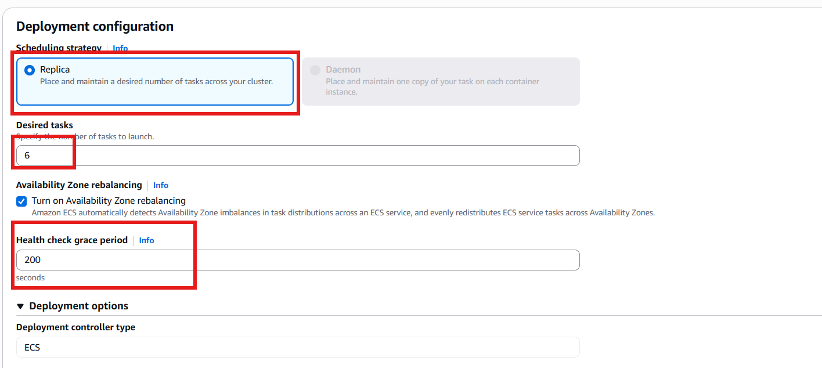

- Load Balancer-
  - Default VPC
  - Type – Application Load Balancer
  - Container- 8080
  - Load Balancer Name- hiring-app-lb
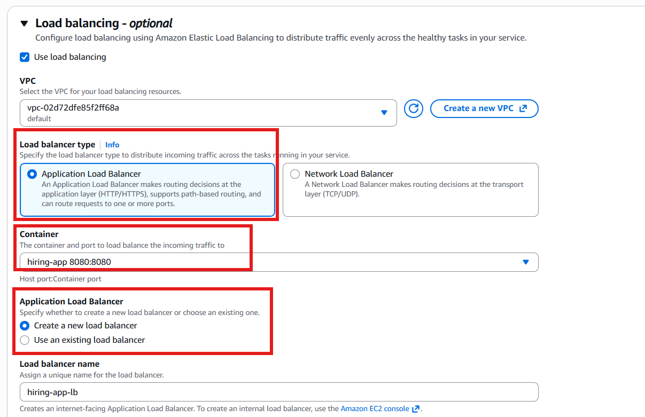

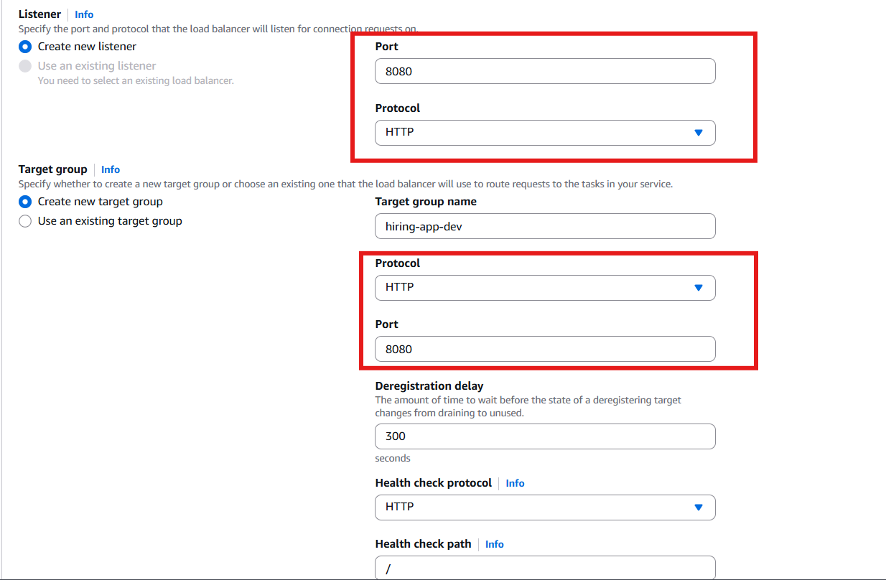

- Minimum- 6
- Maximum-10
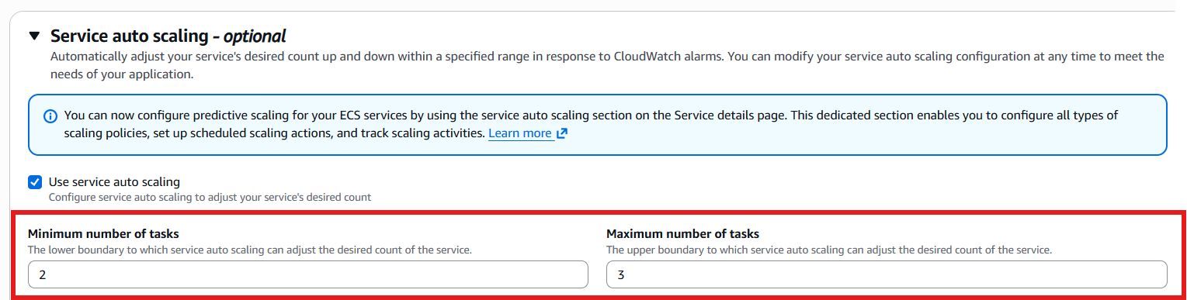
Scaling policy
CPU Utilization for those 2 instances
Target value- 70
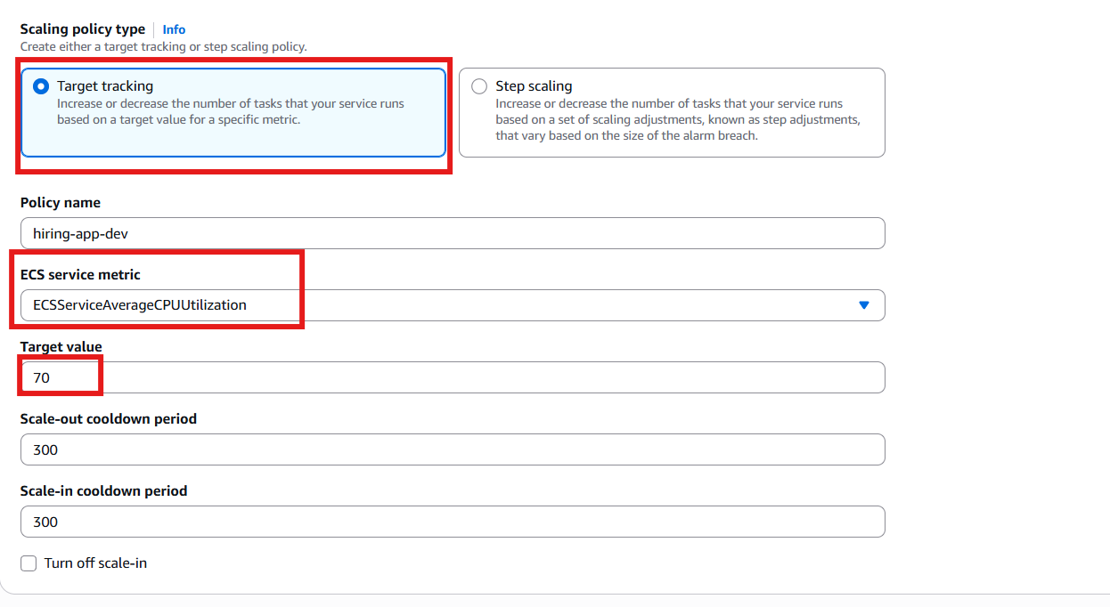

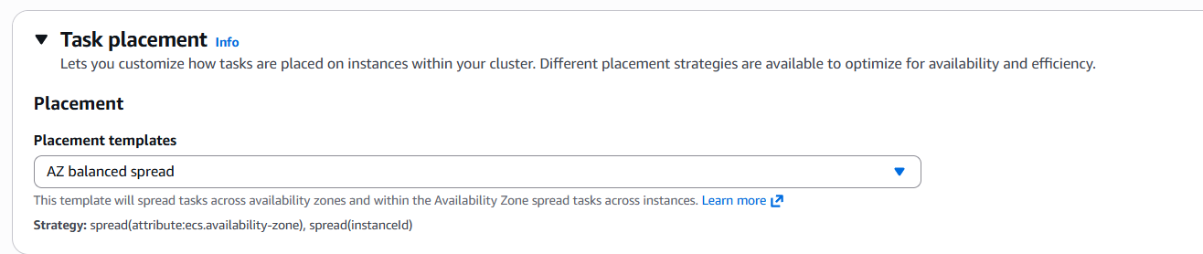

Deployment Strategy
We used Rolling update- because, rolling update will have no downtime and remove 1 versions at a time and create a new instance.

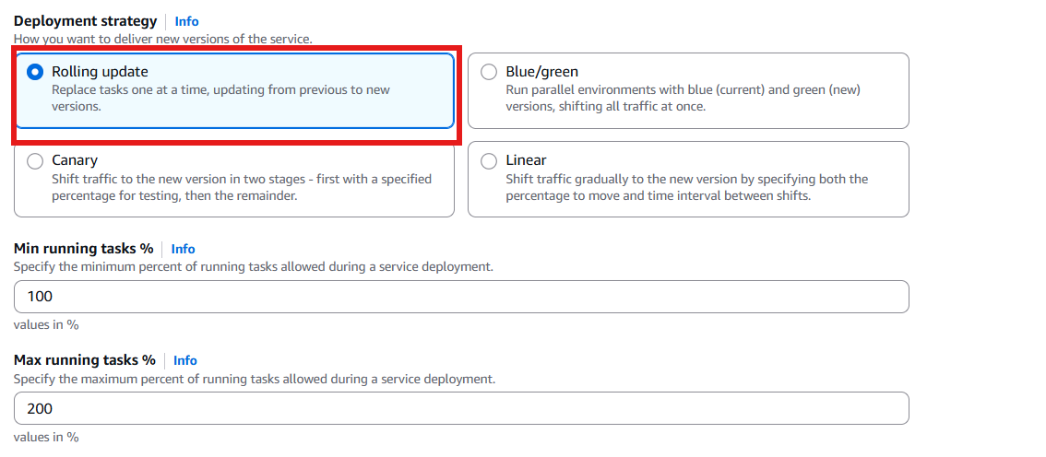

Step 5: Verify if instances create as per healthy checks
- We can see here, 3 containers are healthy and trying to initialize as per our desired 6 value.
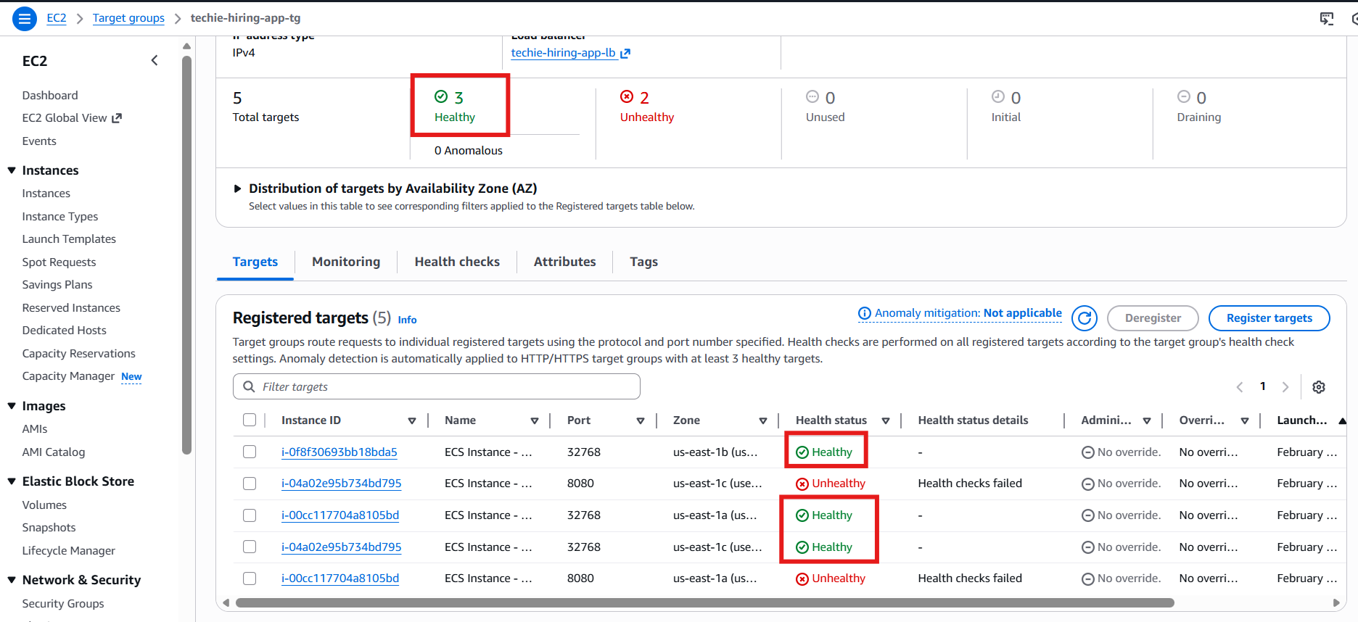

- We can verify in ECS Services hiring-app-task- health
- 3 in Completed Task
- 4 in Progress
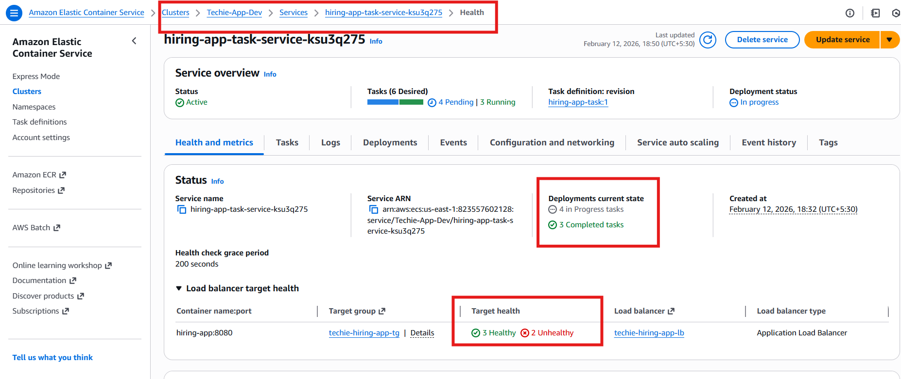

Step 6: In the Tasks- we can verify that, 4 are in provision state and 3 are running.
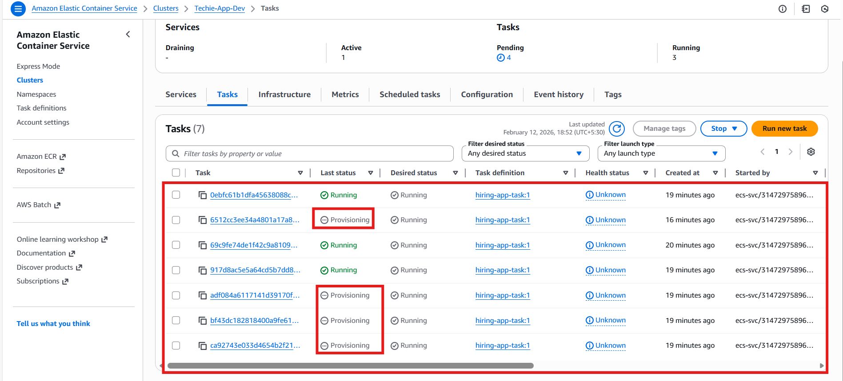

Task completed
Conclusion:
- The application was successfully deployed using Amazon Elastic Container Service with the EC2 launch type to provide full control over compute capacity while maintaining high availability.
- An Elastic Load Balancing Application Load Balancer was integrated with dynamic port mapping so multiple containers could run efficiently on the same instances.
- The ECS service was configured with a desired count of six tasks, ensuring that at least six application replicas remain running at all times. Tasks were distributed automatically across multiple Availability Zones, improving fault tolerance and resilience.
- Health checks continuously monitored container status, and any failed tasks were automatically replaced by the scheduler without manual intervention.
- This design guarantees scalability, reliability, and zero-downtime operation while optimizing infrastructure usage.
- The environment demonstrates how container orchestration, load balancing, and automated recovery mechanisms work together to deliver a production-ready highly available system.

